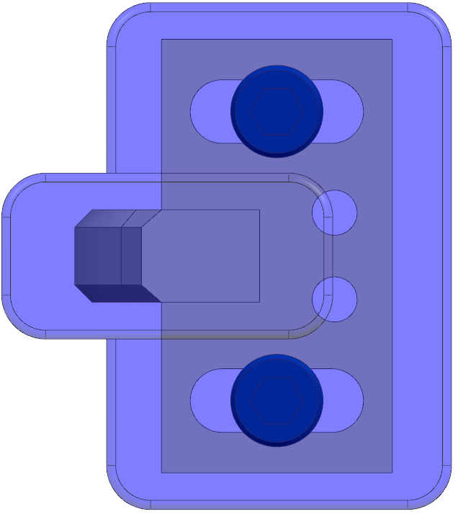
LEFT
RIGHT
FRONT
BACK
FRONT & BACK – Defaults to SlotWidth/2 +.125”

